AGENDA -Mental Health Tax Fund 1100

Date: November 13, 2019
Time: 2:00 p.m.

2020 Prelim. Budget:
- Revenue $1,847,200
- Expenditures $2,320,796 + 258,500 for Nurse Family Partnership
- Estimated use of Fund Balance $473,596
- Program Overview by each Office
- Accomplishments
- Challenges
- Budget Increase Requests (attached)
  - Jail – Prescription costs $81,600
  - Family Recovery Court $8,700
  - Drug Court $81,329

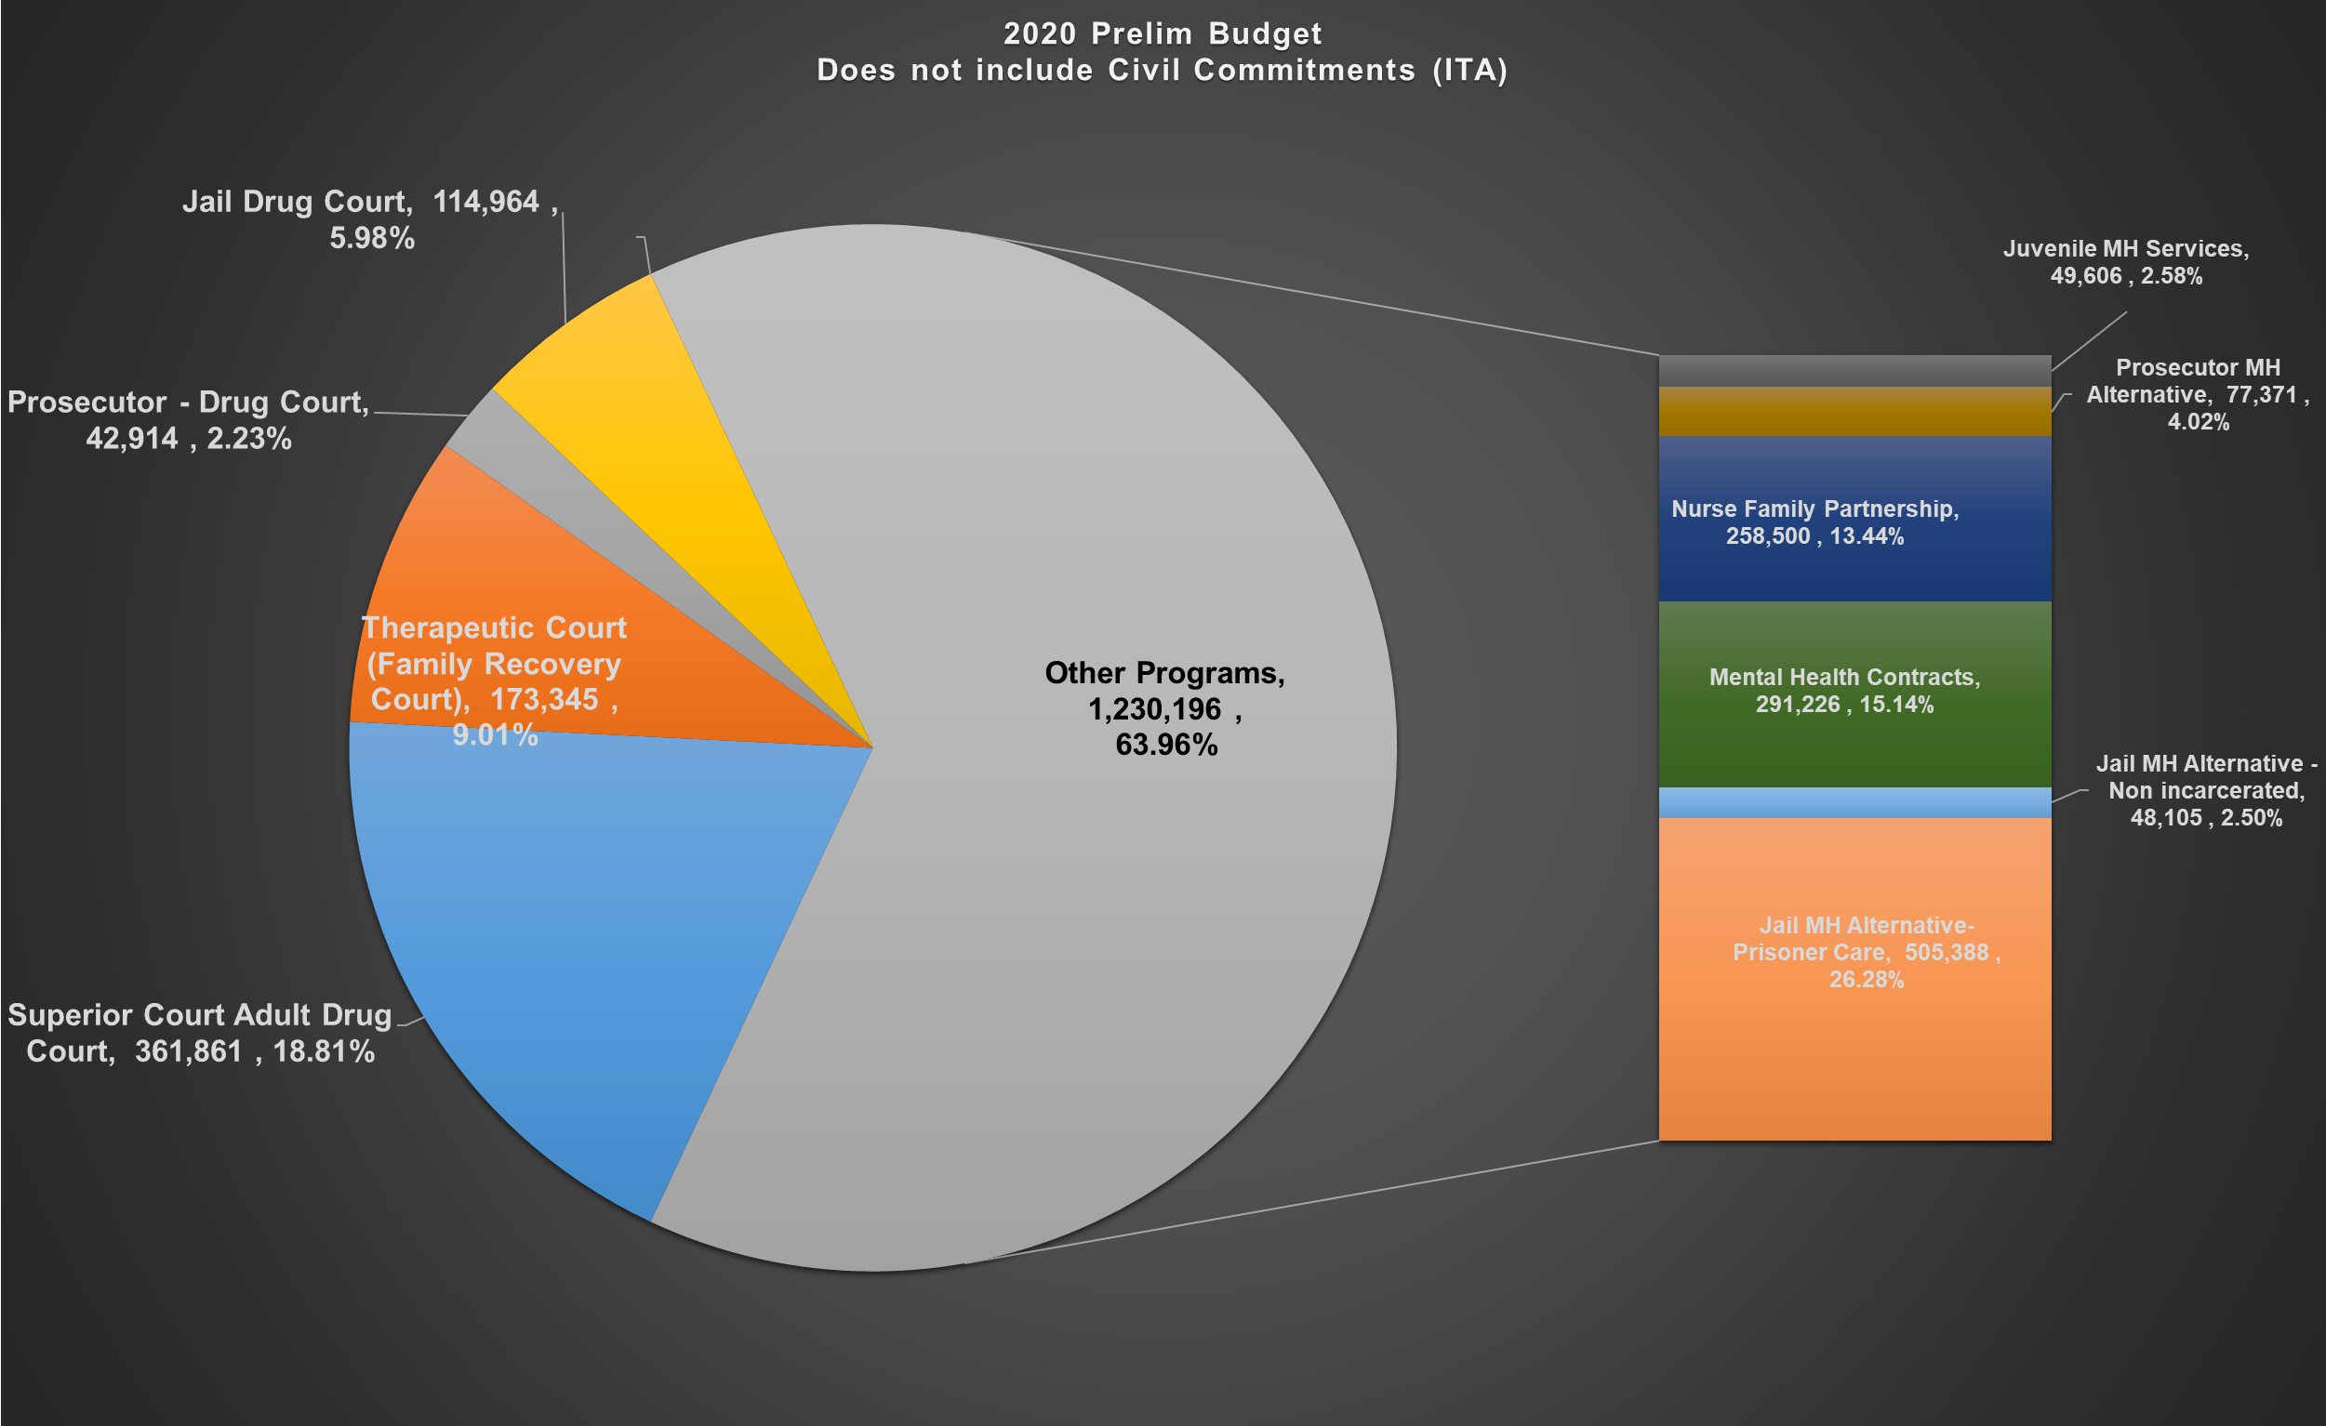

The Chart below includes ALL program costs and funding sources including Civil Commitments (ITA) and the Medication Assisted Treatment program (MAT) in the Jail.

Funding from Cascade Pacific Action Alliance for Medication Assisted Treatment was received in 2019. Additional funding through the BHO for prescriptions in the Jail was received for 2019. This added funding will not be received in 2020, a request from the Jail is attached requesting use of MH tax funds to cover the loss of these grant funds.

The ITA costs are included for years 2018, 2019 and 2020. The initial funding agreement of $750.00 per civil commitment case was authorized April 1, 2018. This reimbursement rate was renegotiated by the Prosecutors Office earlier this year however, the increase in the per civil commitment case rate does not fully cover the cost of the ITA program. The 2020 Preliminary budget has a shortfall in the ITA program of $176,016. Superior Court has requested additional funding for the cost of attorney fees.

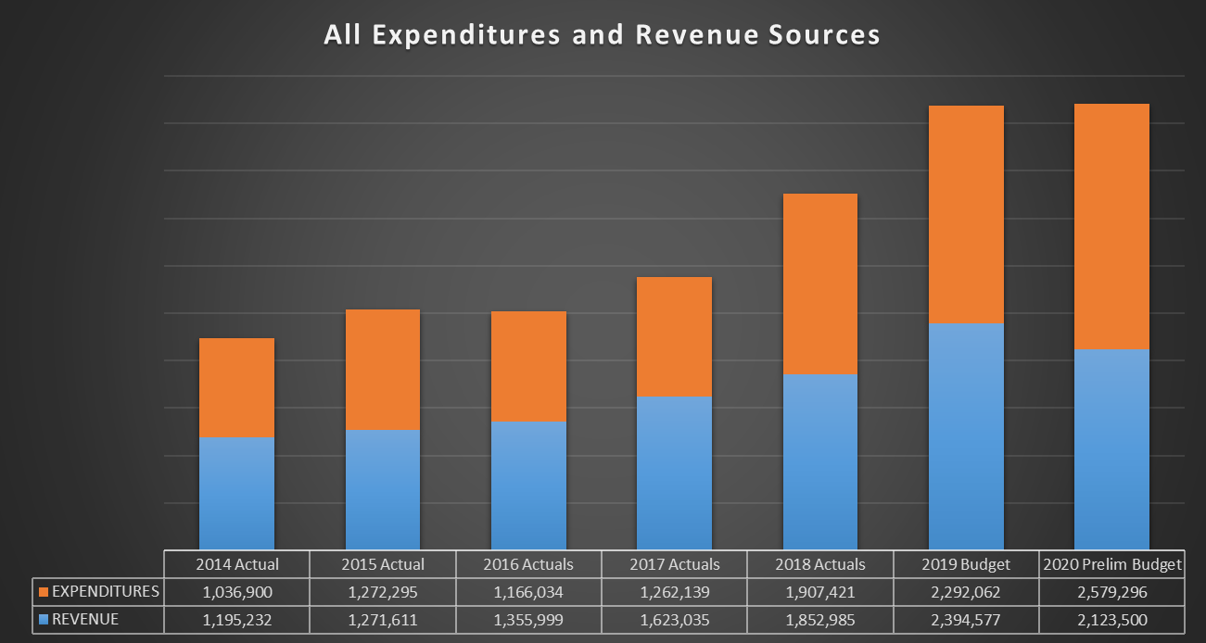

The estimated ending fund balance for 2020 is $1.5 million, this estimate does not include the requested additional funding.

